Organic canned vegetables and wine, main protagonists of the 2nd SME ORGANICS Field visit to Navarra (Spain)

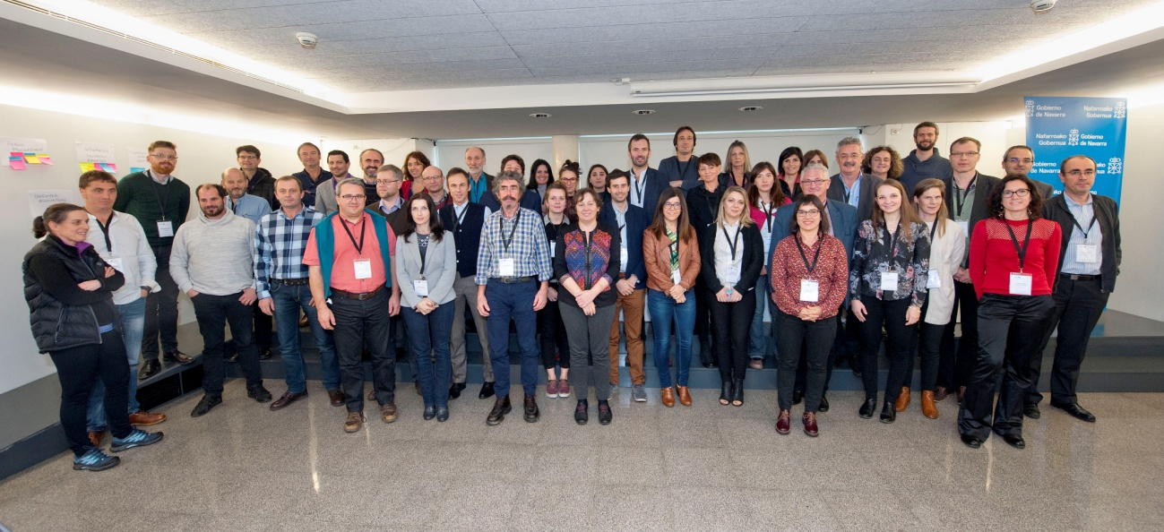Three success stories (Pedro Luis, Gumendi and Organic Winery Quaderna Vía) were the main protagonists of the second SME Organics Field visit to Navarra. In addition partners were able to listen to practical experience from a local stakeholders like Jauregia, Trigo Limpio and Landare. The visit included also 4 workshops in order to discuss and exchange experiences among peers from stakeholders of the different SME Organics regions with focus on addressed policies: Production and Processing; Commercialization and Marketing; Training and Advice; and Organic Value Chain Efficiency and Governance.

The Second Interregional Field Visit of SME Organics Project took place in Navarra (Spain) on 30th November - 1st December hosted by Department of Rural Development, Environment and Local Administration of the Government of Navarra and Regional Development Agency of Navarra (SODENA), in collaboration with INTIA. The visit aimed at knowing real experiences of producers, distributors and associations working in organic production and included the participation of more than fifty project partners and stakeholders.

Good Practices by local stakeholders
The opening session on 30th November, which was attended by the Councillor Ms. Isabel Elizalde, started with a presentation of the regional organic sector and the support measures and policies by Mr. Jokin Resano, Head of the Plant Health and Breeding Material of the Government of Navarra; this was followed by a presentation from Mr. Juan Manuel Intxaurrandieta, General Director of Institute for Agrifood Technology and Infrastructures of Navarra (INTIA), who presented the R&D, training and advice activities in the organic sector of this public company attached to the Government of Navarra.

And then we listened to life experience of three local stakeholders: Jauregia, Trigo Limpio and Landare.

The Valley of Ultzama, in the north-west of Navarre just 25 kilometres from Pamplona, it is an idyllic valley of green meadows, surrounded by oak and beech woods and dotted with tiny, impeccably-kept villages. There, in a very small village named Aniz, Azkarate family have tended their herds since centuries. A few years ago the Azkarate brothers, Mikel and Aitor, began a process of transforming their farm that now allows them to produce milk in an organic way while maintaining the natural values of their land. Actually they have a total organic production producing daily: cheese, yogurt, fresh milk and ice cream. Furthermore they distribute their products by themselves under the trade name of Jauregia through direct sale (vending machine in Elizondo, local markets, consumer groups, internet and schools); retail sale (small shops and specialized stores) and experiential marketing (Km 0, guide visits, etc).

Trigo Limpio started like a cooperative, with a lot of passion but not much management, and then they failed. After a transition years renting a meat processing plant and learning about the profession of butcher, in 2013 built their meat processing plant in Aribe. Gabriel Errandonea shared with the attendance the barriers to organic farming: difficulties to apply the CAP, difficulties to use non OGM cereals, and taxes to organic production. They have an online store and sell veal, lamb, foal meat, potatoes, kiwis and walnuts.

And finally Patricia Andrés talked about Landare case, a Consumers Association of organic products. They are almost 3.000 members and their principles are: committed on values and benefits for the community (agroecology and responsible consumption); direct relation with producers and proximity; transparent prices and clear information; shopping basket (variety, quality and fair prices); and participative organization, motivation and effective management. In the buying process, they have 122 organic producers with long lasting relationships and the 67% products are from Navarra. Patricia concluded exposing their demands: public policies to promote organic production; support to small producers; legislation on GMP; and taking into consideration of the alternative distribution channels by the public Administration and equal treatment.

Visiting competitive organic SMEs - Selected success stories
After a lunch based on organic products, the participants visited three organic SMEs success selected stories: Pedro Luis, organic canned vegetables; Gumendi, production processing and distribution of organic products; and Quaderna Vía, organic winery.

The origin of Conservas Pedro Luis goes back to 1968. Pedro Luis and his wife dulled the fruits they collected from their lands. They made Peppers of the Piquillo of Lodosa and Asparagus of Navarre. Then the range was extended to more than 60 products that are produced nowadays. The son, as well named Pedro Luis, keeps alive the quality spirit of the beginning. All the products are processed in their facilities where raw material comes directly from farmers with the highest commitment with quality and food safety.

Gumendi was born from the union of two farmers dedicated to the organic production of fruits and vegetables in the year 1992. As there were no marketing structures at that time, and in response to this need, they faced the idea of creating a cold store that could give this service not only to their production but also to other farmer’s production. Actually they have a central warehouse for the picking and commercialization of fresh fruits and vegetables with 5000 m2 capacity, seven fridges with controlled atmosphere and four fridges with normal atmosphere.

With a longstanding grape-growing tradition behind them, brothers Raúl and Jorge Ripa completed construction work on their new bodega at the beginning of 2003. This 2,400 square metre building was designed and equipped to obtain high quality wines. It has an "Organic Wine Interpretation" classroom where an audiovisual session explains all the facts about organic viticulture. The bodega markets young and Crianza wines under the "Quaderna Vía" label, all of which are made from grapes from their own vineyards following organic farming systems.

Conference and workshops
The Second Interregional Field Visit of SME Organics Project included in addition two conferences and four parallel workshops. The first conference, “Ways to develop new commercialization channels and structures for small producers/businesses using OAPs” facilitated by Nic Lampkin and Stephen Meredith, included a very interesting brainstorming with ideas to improve the marketing and the commercialization of the organic productions for example, the green public procurement or to increase the information about what is a organic product and its meaning. And the second was about learning from local stakeholder activities to address key challenges/opportunity facing Navarra region.

On the other hand, the workshops were aiming to discuss and exchange experiences among peers from stakeholders of the different SME Organics regions with focus on addressed policies: Production and Processing; Commercialization and Marketing; Training and Advice; and Organic Value Chain Efficiency and Governance. At these sessions participants continued the discussions of the previous sessions in Aargau (Switzerland) and worked on aspects highlighted in the plenary sessions and in the ongoing regional diagnoses, as well as on relevant good practices and policies.

The conclusions of the first workshop included: public support is the key for the success; the importance of linking farmers and the decision makers; and gave an example about a published document in France over health and organic consumption. In the second workshop, commercialization and marketing, participants talked about an idea from Lombardy for building a database of producers and a platform to connect consumers, producers and shops; and we had the opportunity to know the case from Romania: a cluster for local, traditional and organic food. Number three, about training and advice, concluded that organic farming is very dynamic and the development in new generation it depends on different regions and different needs; and participants proposed for the next meeting an important issue: feedback from each region about their needs and their experiences. Finally, the conclusions of the fourth workshop were, the definition of Governance; the interaction both public and private organisms; evaluation of benefits of the public procurement (with examples from different regions); good connection public actors, associations, private companies, etc; and gather information about interesting topics from the regions “for homework”.

The working day ended up with a Plenary session facilitated by Nic Lampkin and Stephen Meredith to bring together key experiences and best practice lessons to be learned.

SME Organics Consortium Meeting
Both days, a Consortium Meeting took place just for Partners to discuss about progress and next steps on exchange of experience. The first day, Leire Iriarte and Stephen Meredith made the introduction and later on each region explained their progress on draft regional diagnosis; and the second day, Iñaki Goñi presented the Communication Strategy and the partners explained how the Strategy has been adapted to each Region. Finally, Daniel Mazo, exposed important aspects of the management and finance.

All the presentations are available in http://www.interregeurope.eu/smeorganics/library/.

About SME ORGANICS

The overall objective of SME ORGANICS is to improve policies and programmes under the Investment for Growth and Jobs goal in order to enhance the competitiveness and sustainability of the SMEs in the organic sector of the participating regions. The project aims both at enhancing entrepreneurship but also at supporting the existing SMEs in improving their performance in order to enforce the growth capacity of the entire organic regional sector in regional, national and international markets.

The project specific objectives are:
- To conduct regional diagnosis based on a SWOT analysis of the organic sector of the participating regions, evaluating the existing support measures and policies, regulatory framework, SMEs needs, etc, in four large thematic areas: i) production and processing, ii) commercialization and marketing, iii) training and advice, iv) organic value chain efficiency and governance.
- To mobilize relevant stakeholders at the regional level in the above mentioned areas in order to include their contributions in the development of the Regional Action Plans.
- To carry out the exchange of experience and interregional learning among project partners and regional stakeholders in the above mentioned areas.
- To carry out the strategic thinking processes at regional level in order to identify the relevant measures (from the interregional learning process) to be integrated into the regional policies, the activities needed for this integration, timeframe and responsible actors.
- To identify the synergies and complementarities between different policy and funding instruments (ERDF, ESF, EAFRD) in order to optimize their joint utilization at regional level.
- To develop Regional Action Plans with tailored funding and policy mixes, including: clarification of the motivations behind the policy objectives and measures, clear and specific objectives, an analysis of the conflicts and synergies of possible policy measures, quantified indicators, monitoring and evaluation procedures.

In order to successfully achieve theses objectives over the 4-year duration of the project (2 years to develop the organic action plans and 2 years of implementation) 8 stakeholders workshops will be organised in each region (one per semester) and partners and stakeholders will participate in the field visits of all the regions, where each host regions will present their policy measures and programmes relevant to the organic sector. In addition, regional and interregional dissemination events will be organised to transfer and promote the project’s results and outcomes.

SME ORGANICS is lead by the Regional Development Agency of Navarra (SODENA) and has an overall budget of 2.289.834 €. It is supported by the EU through the Interreg Europe Programme (ERDF funds) with 82,77% of co-financing (1.895.914€).

Regional governments and development agencies
- Navarra Government’s Dept of Rural Development, Environment and Local Administration and Navarra’s development Agency - SODENA (lead partners) (ES)
- Lodzkie Region Marshall's Office (PL)
- Puglia Region Managing Authority (IT)
- North-West Regional Development Agency (RO)
Organic food and farming and enterprise bodies
- International Federation of Organic Agricultre Movements (IFOAM EU) (advisory partner) (BE)
- INTERBIO Nouvelle Aquitaine (FR)
- Union of the Chambers of Commerce, Industry, Agriculture and Crafts of Lombardy (IT).
Research Institutes
- CIHEAM MAIB Mediterranean Agronomic Institute of Bari (IT)
- Seinäjoki University of Applied Sciences (South Ostrobothnia-FI)
- FiBL Research Institute of Organic Agriculture (Aargau-CH)

FOR FURTHER INFORMATION, CONTACT:

Marta BORRUEL, INTIA
SME ORGANICS Communication
+34 948 013 040, mborruel@intiasa.es

Josefine JOHANSSON, IFOAM EU
SME ORGANICS EU
+32 (0)2 808 7991, josefine.johansson@ifoam-eu.org

